Chemistry 12 - Organic Families
Chapter 6.1 Organic families
- Can organic compounds be made from inorganic compounds? Give an example.
________________________________________________________________________________________________________________________________________________________________________________
- What percentage of chemical compounds are organic compounds? _______

- Explain the difference between synthetic and natural organic compounds.
__________________________________________________________________________________
__________________________________________________________________________________

- Explain why the type of atoms present in a molecule as wells their overall shape is so significant to the chemistry of organic substances.
__________________________________________________________________________________
__________________________________________________________________________________

- What determines the 'family' that a particular organic substance belongs to? Name three families.
__________________________________________________________________________________
__________________________________________________________________________________

- Why is it helpful to know what family a molecule belongs to?
__________________________________________________________________________________
__________________________________________________________________________________

- Why is the ball and stick model preferred over the space filled model? Identify each of the types of models from the pictures below.
__________________________________________________________________________________
__________________________________________________________________________________
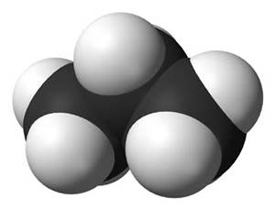
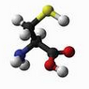
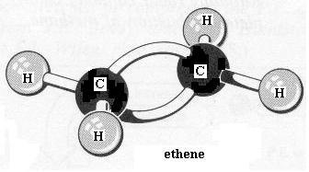

____________ ______________ ___________________

- Why is the space filled model actually more realistic even though organic chemists prefer ball and stick?
__________________________________________________________________________________
__________________________________________________________________________________

- Fill in the table below.

Bonds around C atom | Geometric Shape | Geometric shape and angles between bonds
Four single bonds

One double bond and two singles

Two double bonds
One triple bond and one single

Chapter 6.2 Hydrocarbons and 6.3 Branched Chain Hydrocarbons (Two Chapters Combined)
- What is a hydrocarbon? Give some examples.

______________________________________________________________________________
______________________________________________________________________________

- Practicing alkene nomenclature:
i. Which of the molecules below is 3,4-dimethylpent-2-ene?
A.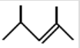 B.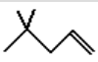 C.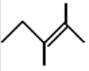 D.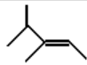
ii. Which molecule is 3-ethylpent-2-ene?
A.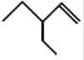 B. 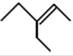 C.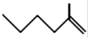 D.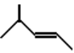
iii. Which molecule is 5-methylhex-1-ene?
A.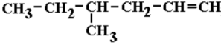 B.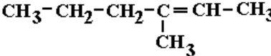 C.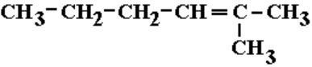 D.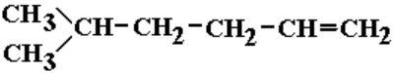
iv. Which molecule is 3,3-dimethylpent-1-ene?
A.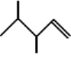 B.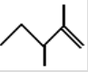 C.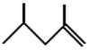 D.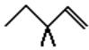
v. Which molecule is 3,4-dimethylpent-1-ene?
A.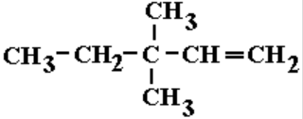 B.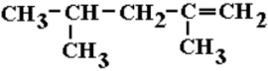 C.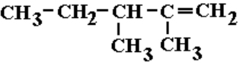 D.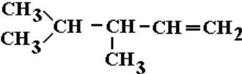

vi. Which molecule is 2-methylpent-2-ene?
A.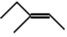 B.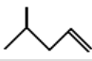 C.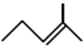 D.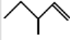
vii. Which molecule is 2-methylbut-2-ene?
A. 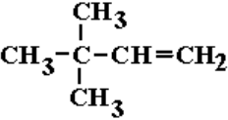 B.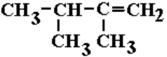 C.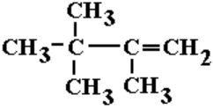 D.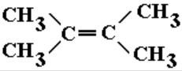
- Name the following molecules.

a. ____________________________

b.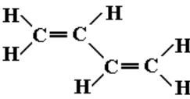______________________________

- Fill in the table below.
Use the word bank: (some words are used more than once)
Saturated, Hydrocarbons, Unsaturated, Alkanes, Cycloalanes, Aliphatics, Cycloalkenes, Alkynes, Chain, Alkanes, Cycloalkynes, Cyclic, Aromatics
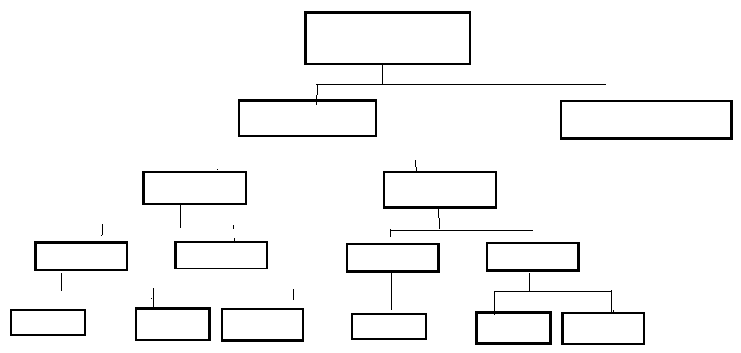
- Naming of alkane side groups
No. of C | 1 | 2 | 3 | 4 | 5 | 6 | 7 | 8 | 9 | 10
Stem name

Other common side groups are:
Side group | F | Cl | Br | I | NO₂
Name of side group

- Naming alkanes, alkenes and alkynes
a) Look for a functional group (i.e. double bond or triple bond).
b) Look for the longest chain attached to this functional group and start numbering such that the functional group has the lowest number in this longest chain.
c) Determine the location (carbon number) of all the side groups and start the naming of the compound with the side group that is closest to the start of the alphabet. Put comas between numbers and a dash between words and numbers. Notice it is the name of the side group not the di, tri etc. that determines the order in a name.
i.e. 1,2,2-tribromo-3,3-dimethyl hexane
- Classify the compound then name it.
Compound | Aromatic/Aliphatic | Chain/Cyclic | Saturated/Unsat | Name
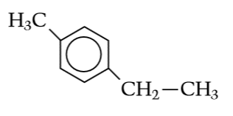
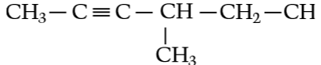
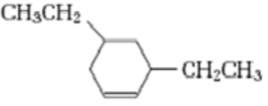
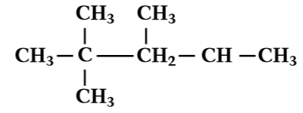
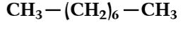
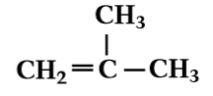
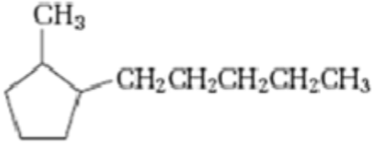
Practice naming aliphatics and aromatics at:http://hrsbstaff.ednet.ns.ca/benoitn/chem11/units/4.%20Organic/unit_organic.htm
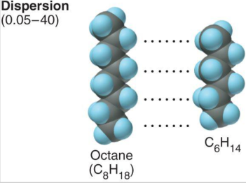
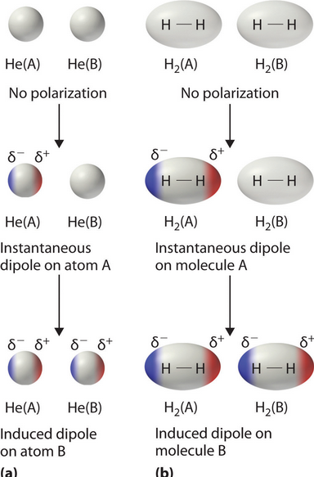
Structure and Bonding of Hydrocarbons
- What are dispersion forces? How does this type of force relate to hydrocarbons.
_______________________________________________________
_______________________________________________________
_______________________________________________________
_______________________________________________________
_______________________________________________________
_______________________________________________________
_______________________________________________________
- Are dispersion forces, intramolecular or intermolecular forces.
______________________________________________________
______________________________________________________
- Explain what a non-polar molecule is and why dispersion forces are important to non-polar molecules.
_______________________________________________________________________________________
_______________________________________________________________________________________
_______________________________________________________________________________________
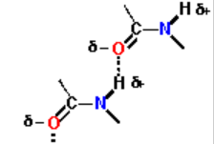
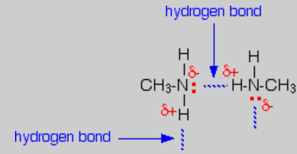
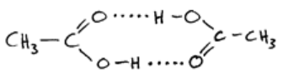
- What types of atoms inside organic compounds can cause hydrogen bonding forces to occur.
_________________________________________
- Are hydrogen bonding forces stronger or weaker than dispersion forces?
_____________________________________________________________________
- Explain how the additional effect of hydrogen bonding could affect properties such as melting and boiling point, and solubility in water.
__________________________________________________________________________________
__________________________________________________________________________________
__________________________________________________________________________________
__________________________________________________________________________________
__________________________________________________________________________________
__________________________________________________________________________________
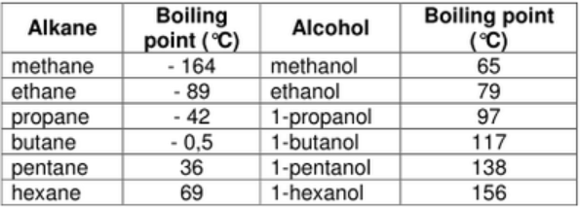
- Explain how size of a hydrocarbon could affect melting and boiling point as well as solubility if it is a substance that can undergo hydrogen bonding.
_____________________________________________
_____________________________________________
_____________________________________________
__________________________________________________________________________________
__________________________________________________________________________________
__________________________________________________________________________________

- Which compound in each pair would be more soluble in water? Explain your answer.
- Ethanol or ethane?
__________________________________________________________________________________
__________________________________________________________________________________
__________________________________________________________________________________
- Ethanoic acid or ethanol?
__________________________________________________________________________________
__________________________________________________________________________________
__________________________________________________________________________________
- Ethane or Hexane?
__________________________________________________________________________________
__________________________________________________________________________________
__________________________________________________________________________________

- Which organic compound would have a higher density and which will have a lower boiling point? Explain your answer.

- 2,2 dimethyl butane or butane?
__________________________________________________________________________________
__________________________________________________________________________________
__________________________________________________________________________________
__________________________________________________________________________________
__________________________________________________________________________________

- Oxalic acid or pentane?
__________________________________________________________________________________
__________________________________________________________________________________
__________________________________________________________________________________
__________________________________________________________________________________
__________________________________________________________________________________

Isomers of Alkenes
- Describe the difference between a structural isomer and a geometric isomer.
__________________________________________________________________________________
__________________________________________________________________________________
__________________________________________________________________________________
- Draw four structural isomers of C₅H₁₂ and name these isomers

- Draw two geometric isomers of C₃H₆

- Draw both structural and geometric isomers of C₄H₈

- State the difference between cis and trans.
_________________________________________________________________________________
_________________________________________________________________________________

- Look at the data below for cis and trans but-2-ene and identify which geometric isomer is more tightly packed and has stronger dispersion forces and why dispersion forces might be higher.
Compound | Melting pt. (ºC) | Boiling pt. (ºC) | Density (g/mL)
Cis-but-2-ene | -139 | 4 | 0.615
Trans-but-2-ene | -105.6 | 1 | 0.598

_________________________________________________________________________________
_________________________________________________________________________________
_________________________________________________________________________________
_________________________________________________________________________________

- Comparing and contrasting the properties of Alkanes, Alkenes and Alkynes
Property | Alkane | Alkene | Alkyne
Electrical conductivity
Melting and Boiling pt. | ______________________  ______________________  ______________________  ______________________  ______________________ | ______________________  ______________________  ______________________  ______________________  ______________________ | ______________________  ______________________  ______________________  ______________________  ______________________
Solubility | _______________________  _______________________ | _______________________  _______________________ | _______________________  _______________________
Combustion reaction
Substitution reaction | ______________________  ______________________  ______________________  ______________________  ______________________
Addition reactions |  | ______________________  ______________________  ______________________  ______________________  ______________________ | ______________________  ______________________  ______________________  ______________________  ______________________

Chapter 6.4 Aromatic Hydrocarbons
- Describe some of the unique features of the benzene ring found in all aromatics.
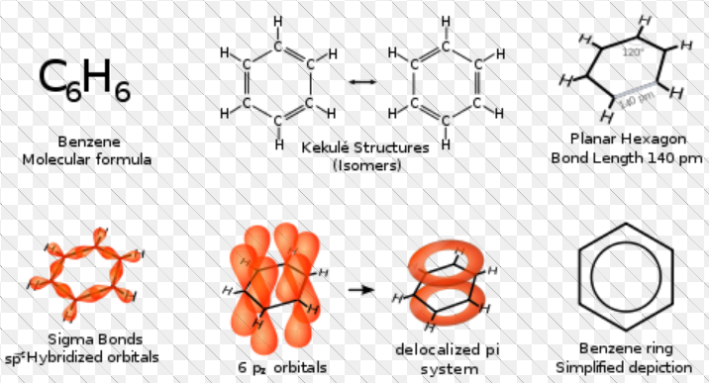
_______________________
_______________________
_______________________
_______________________
_______________________
_______________________
_______________________
_______________________
_______________________
__________________________________________________________________________________
__________________________________________________________________________________

- Describe how the unique features of benzene affect the reactions aromatic substances undergo.
__________________________________________________________________________________
__________________________________________________________________________________
__________________________________________________________________________________

Chapter 6.5 Functional Groups:
- It is important to be able to identify the following functional groups. Remember the functional group determines what you will consider to be the longest chain and will affect the ending of the substances name.

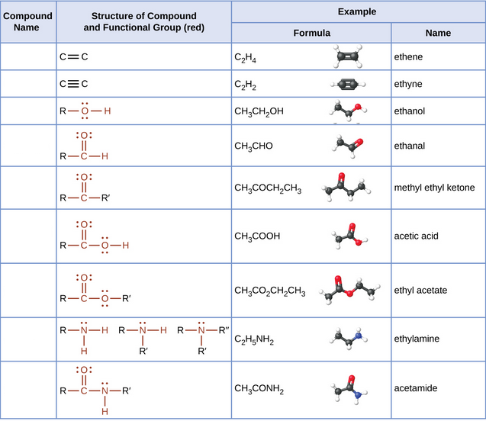
- Fill in the table below.
Substances configuration | Priority Functional Group | Name
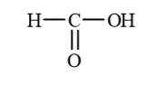
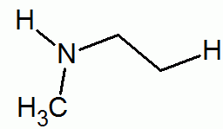
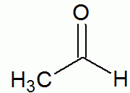
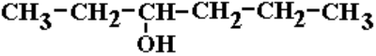

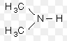
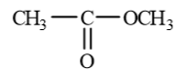
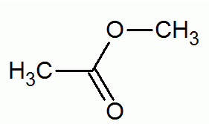
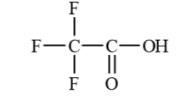
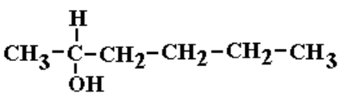
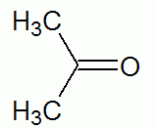
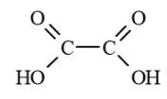
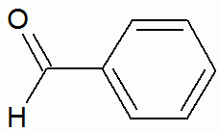
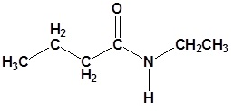

- Describe the difference between a primary, secondary and tertiary alcohol.
______________________________________________________________________________________
______________________________________________________________________________________
______________________________________________________________________________________
- Identify whether the following alcohols are primary, secondary or tertiary alcohols.
- ____________________________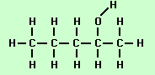
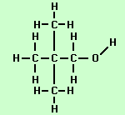

- ____________________________
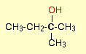
- ___________________________

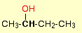
- __________________________
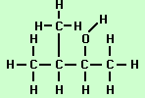
- ____________________________
- ________________________________

- ________________________________
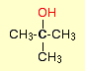
- ________________________________

- Compare and contrast the melting point, boiling point and solubility in water of the following compounds.
Organic Compound | Melting Point (M.P.) and Boiling Point (B.P.) | Solubility in Water
Butane
1-Butanol or But-1-ol
2-Butanol or But-2-ol
But-1,4-diol
2-Methyl-2-propanol

Organic Compound | Melting Point (M.P.) and Boiling Point (B.P.) | Solubility in Water
Butanal

2-Butanone
or
But-2-one

Butanoic acid

Ethylethanoate

1-butanamine

Organic Compound | Melting Point (M.P.) and Boiling Point (B.P.) | Solubility in Water
Ethylethanamide

- a) Rank the following organic compounds in the order of their decreasing reactivity with sodium.

Butane, 1-Butanol, 2-Butanol, But-1,4-diol (1,4-Butanol), 2-methyl-2-propanol

_____________>_______________>_______________>______________>_______________

- Rank the following organic compounds in the order of their decreasing reactivity with an oxidizing agent such as acidified dichromate ions.

Propane, 1-Propanol (or Prop-1-ol), 2-Propanol (or Prop-2-ol or Isopropanol (CH₃)₂CHOH)

_________________>____________________>__________________>__________________

- Review the rules for naming substances using p. 92 of the WACE Study Guide.
Note: The main thing to add to what the students learned last year is the order of priority for naming substances. For example if a substance has a carboxyl group than the longest chain attached to the carboxyl group determines that end part of the substances name. The priority is:
1. Carboxylic acid 5. Alchols
2. _________________ 6. Amines
3. Aldehydes 7. Alkenes and Alkynes
4. Ketones 8. Alkyl groups and halides

